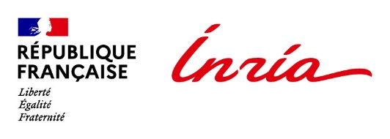


International Relations Department

Inria International Chair Program
Application – Summary sheet

Applications will include this summary sheet and the following documents:
- Passport copy
- Detailed CV
- Research project for the duration of the Chair, including possible technology development and transfer opportunities
- Work plan indicating the planned visiting periods during the Chair, and the total duration of the Chair
- The written authorization from their main employer stating that they authorize the holder of the chair to carry out their stays at Inria and receive remuneration under an Inria contract during their periods of presence at Inria
- Letter of support from the Inria project team leader
- Recommendation letters or references from international experts can be provided
- For starting career only: an attestation of their commitment to developing international collaborations
- For starting career only: a letter of support from their institution
Last Name
First Name
Date of birth (day/month/year)
Place of birth (City and Country)
Nationality
Email
PhD: date of defense
Host Inria project team
Host Inria Center
Current employer
Current tittle
Research domain
Title of the Chair’s research project
If applicable: involvement in an existing collaboration with the Inria team (Associate Team, existing international partnership, European Project…). If yes specify the name of the collaboration.

